Lesson 4: The water cycle
Worksheet:

Understanding the water cycle
- Complete the diagram.
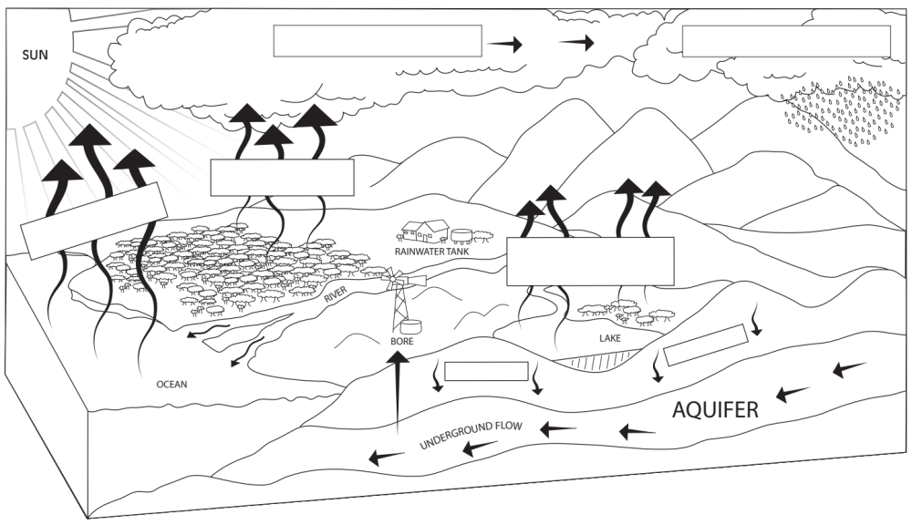
- a. Which processes separate fresh water from the natural solutions and mixtures?

b. What phase change does the water undergo during this process?

- a. What phase change occurs for the water to form clouds?

b. Is the water in clouds fresh water or salt water? Why?

- What is the phase change that produces rain?

- a. Which separation technique is most like the processes considered?

b. Describe the similarities and differences between the separation technique and the water cycle.

- What separation technique is infiltration similar to? Why?

- Explain why water is considered to be a renewable resource. Refer to the diagram to support your answer.

